ODHS Taskphase-8

Shashwat Harsh|220953028

🔴🔴🔴TASK 8🔴🔴🔴

This is your final task which will help you understand the software we work with.

You need to download the STM32CubeIDE application and use the HAL library to turn the BLUE LED on and off.

Refer this video on the installation and basics- <https://www.youtube.com/watch?v=QmqOMGdr7DE>

Feel free to refer to other videos online as well.

The microcontroller you have to use is STM32F407VGT6.

You will also have to refer to the schematics of this microcontroller to find the the corresponding GPIO pins for the led -

<https://www.st.com/content/ccc/resource/technical/layouts_and_diagrams/schematic_pack/group1/0f/91/8b/39/b3/78/4d/c4/MB997-F407VGT6-B02_Schematic/files/MB997-F407VGT6-B02_Schematic.pdf/jcr:content/translations/en.MB997-F407VGT6-B02_Schematic.pdf>

Prepare a report explaining the various steps needed to be done. Make sure to explain what clocks, GPIO pins are used.

Also refer to the datasheet of the microcontroller to have a basic understanding.

Feel free to approach any one of us for doubts.

Deadline: 1st January 2024, Time: 23:59

STM32cubeIDE download link :- <https://www.st.com/en/development-tools/stm32cubeide.html?dl=2b%2B5N1fzUeYEGgl6r9inSw%3D%3D%2CI%2Brc1m8aXp1k6xbEFXrqSDP9HbQr0JZNI5KHuRUzmPtdRioJ2zfOJHdm2FOou1sWou6e9yZp%2Fdtz3XZ30xTU9rh9JMNzWSdNCUaJdN7vqaWl3DD4HxJjdzDu8LVYlke%2FIrmFoAhWNw896ve6XcF7UGsrm1lCl9mp5JZ9gvWFtJATIq7U19YEGce03%2FQahqkFGilGeMPNxecqQ2z7U06oftFbcgToPb8n5H%2B4yeE%2Fhz1T03gH0Ekwidc1OWkx8vLC0udkkCfl2X%2FJMc6ZRLJFUV3IKm%2FKoOmlsNwaC1U8idct18UWGfKeC%2FGvQZzkllilI6aITZZd5EFSgdHq2wPwcVxQ4MXtQJF3ID%2BEvWESITdTjS9YMghv5yfT9NTBnhy%2FsoT%2FgEunqSw1lHxYuOSRH2FHP5%2ByfTBuChCfM%2FG%2FuSH10OatZDIeRZuxyS0ietdfoIxPk%2Fx4PSKK7ACrH6mkbg%3D%3D&mkt_tok=ODU2LVBWUC03MTUAAAGQQG2NWIpd3i0JzFa06CC-vj2xSWwHcY38h61cOi38RbgiDCz4JIgLeGfXPSAYEqjgFeqbVk2gQA8YZYWCUxeyv8V6uNmFea0m8a1XTa36Tw>

1. Open STM32cubeIDE and go to file> new> STM project to open a new project
2. select STM32F407VGT6 as the microcontroller and save the project.
3. In pinout and configuration select a pin of the controller that can do GPIO output. In this case pinout PA0 is used and is set to GPIO_output.
4. 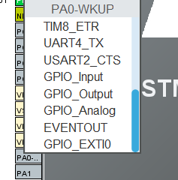
5. Now the clock frequency is set. Under system core> RCC(reset and clock controller) , select crystal/ceramic resonator for high speed clock. (how to change clock parameters?)

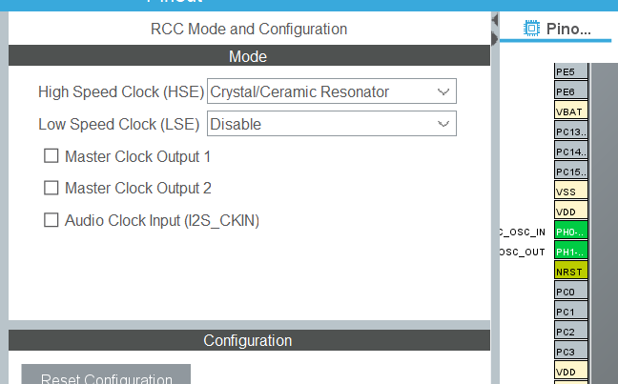

Clock parameters(how to change?):-

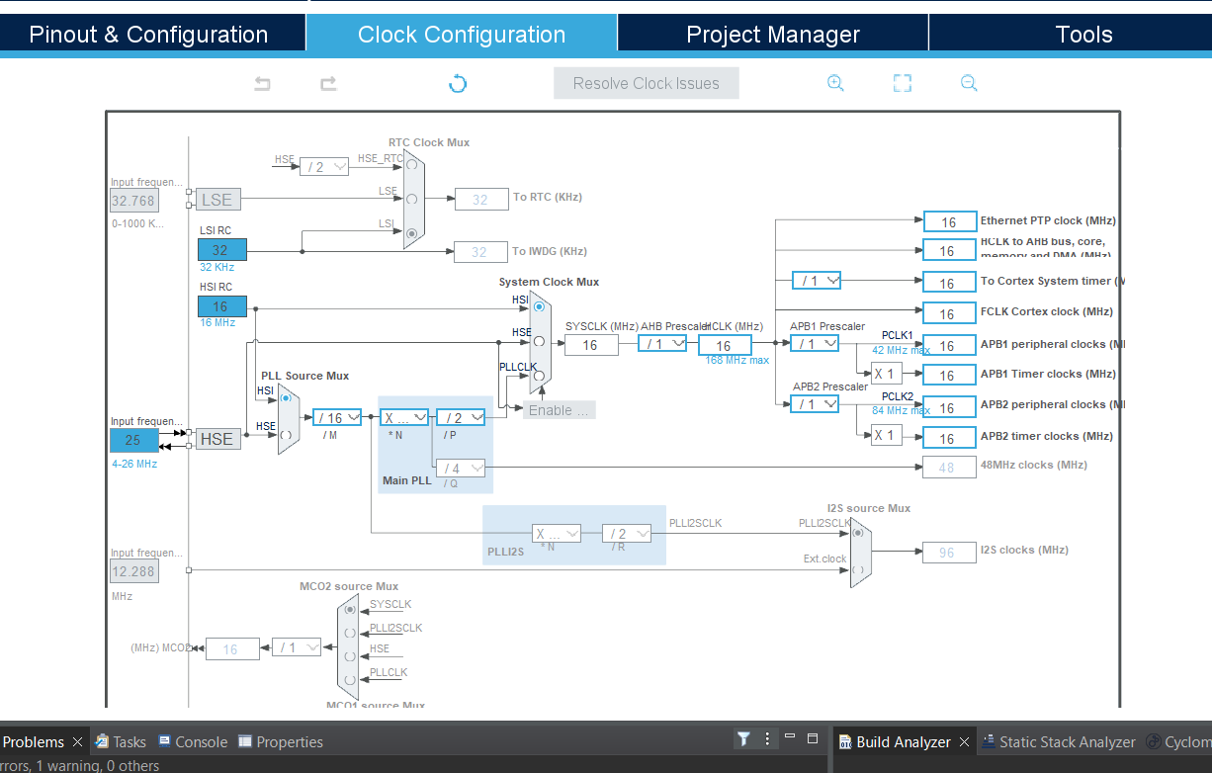

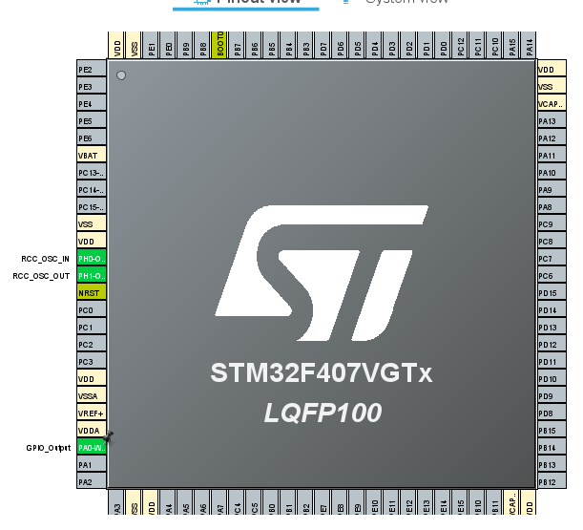

1. the code generation button used to generate the code for the project.

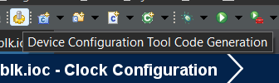

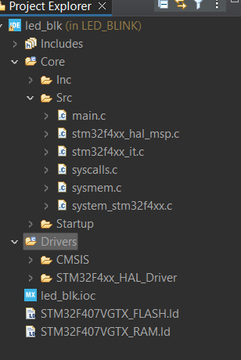

1. open main.c file and in the main function, add the code to be executed using the pre generated functions in the Drivers>STM32F4xx_HAL_Driver>Src>stm32f4xx_hal_gpio.c

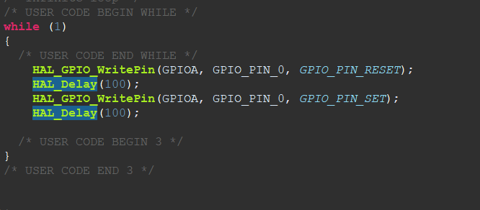

1. debug the code

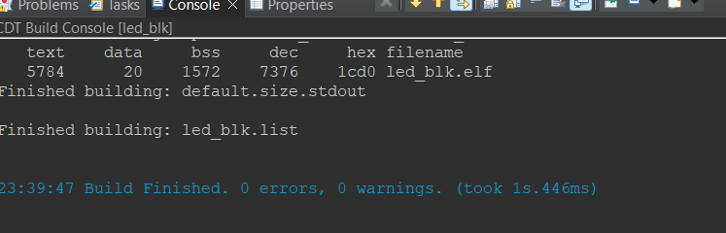

1. now to convert the code into hex file, goto project>properties

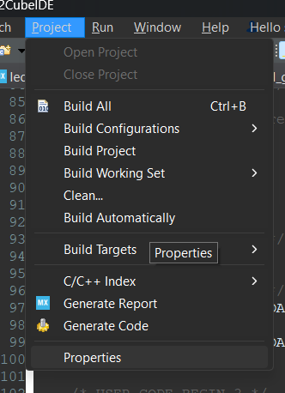

Under properties, go to c/c++ build>settings and under tool settings tab select MCU post build outputs. Here check the ‘convert to Intel Hex file’ click on ‘apply and close’.

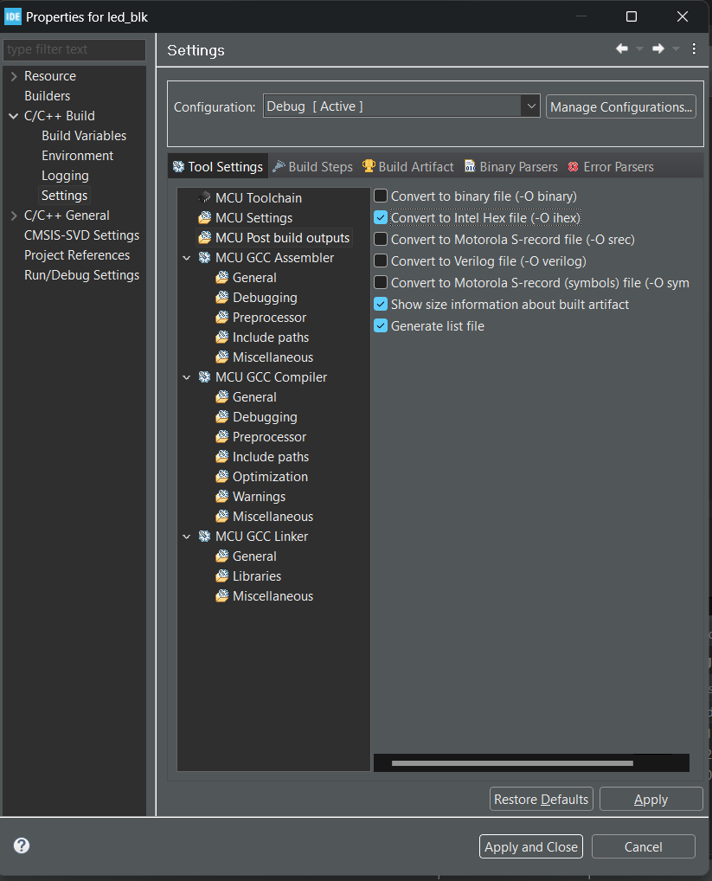

1. Now release the code

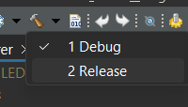

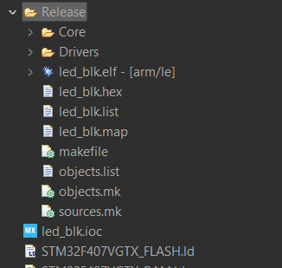

A new folder Release will be created in which the .hex file is present.

(download proteus from geekforgeeks link link on main website not available)

(the STM32F407VGT6 was not present in proteus so its model needs to be downloaded see resource 6 )

1. Open proteus and create a new project
2. Under library open pick parts

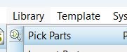

1. Find the microcontroller and click ok and paste it in the workspace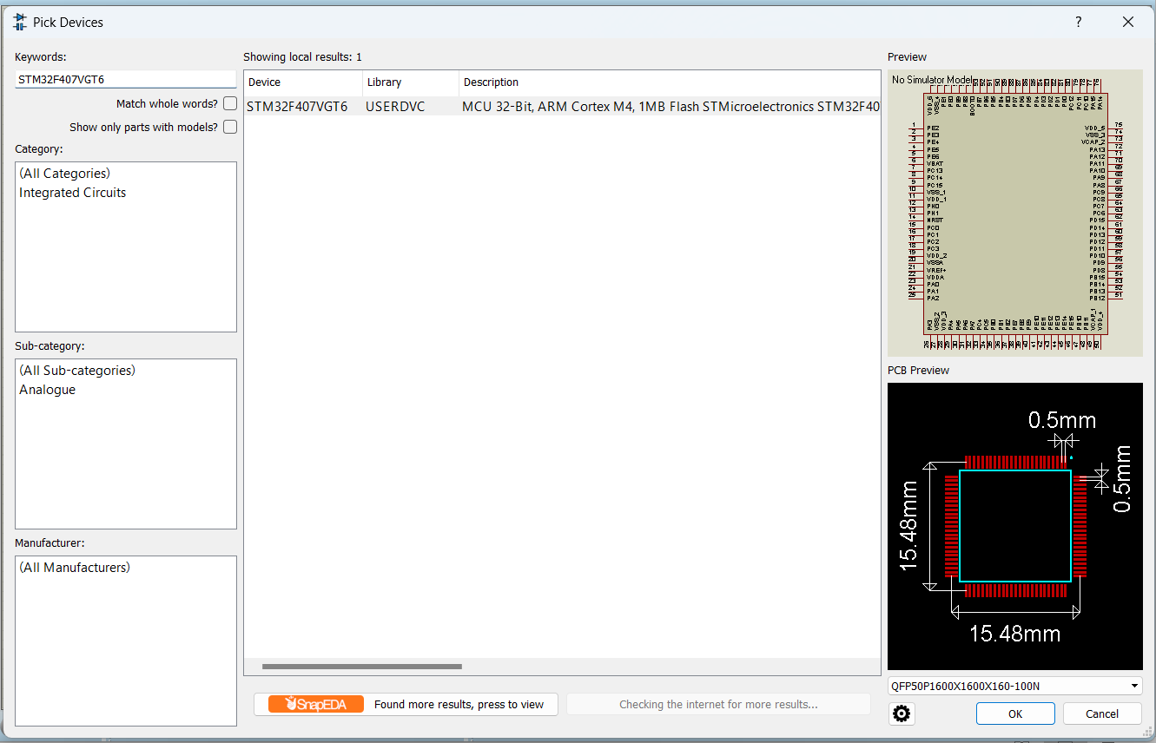
2. Similarly add an blue led to workspace and connect it to PA0 as shown (to connect ground, right click>place>terminal>ground 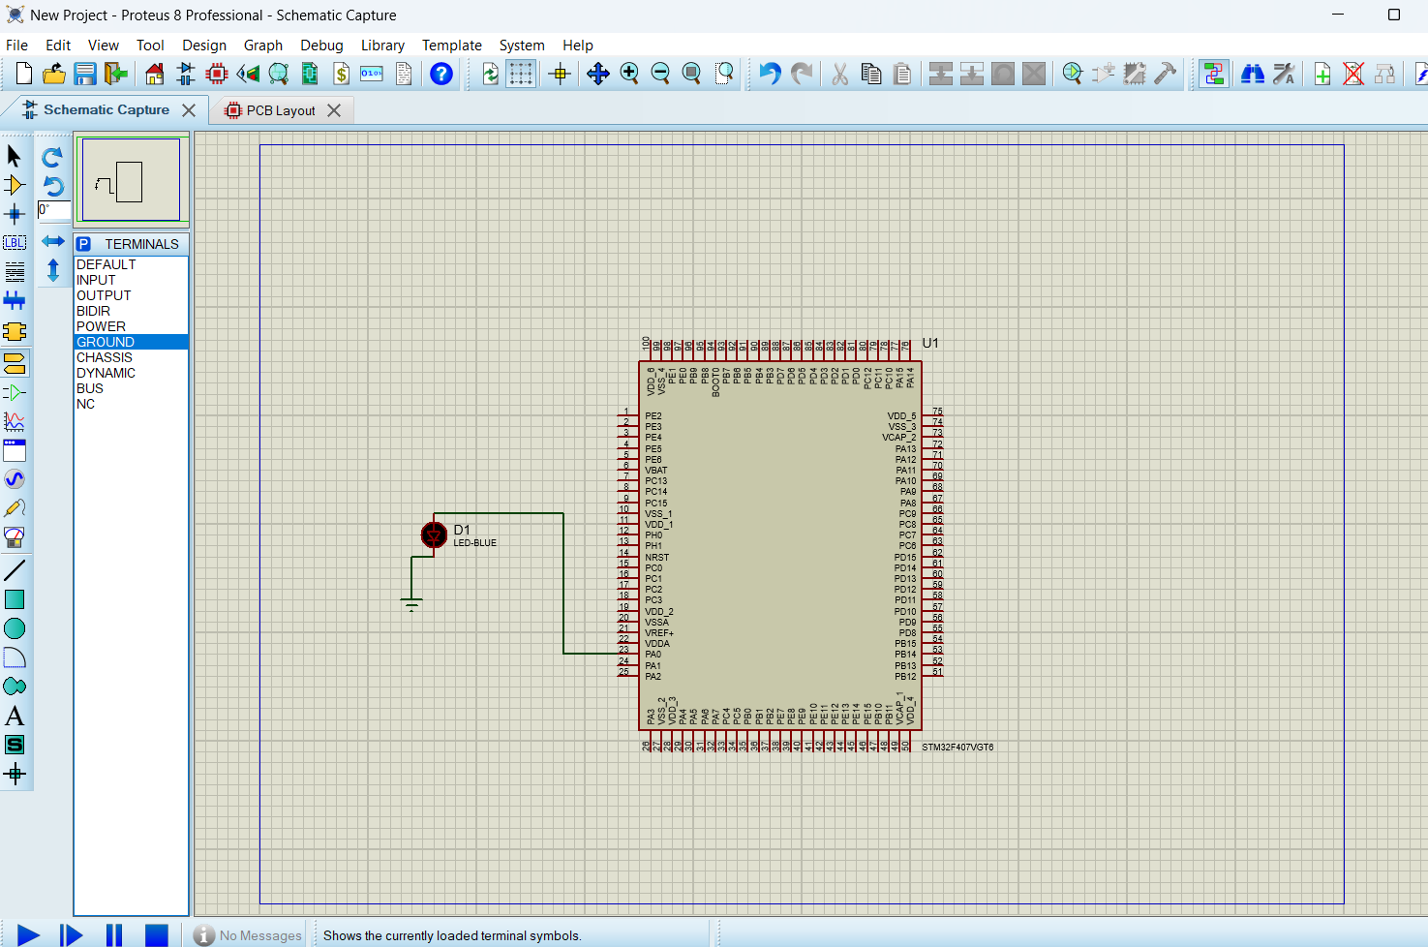
3. Now to connect power to the controller 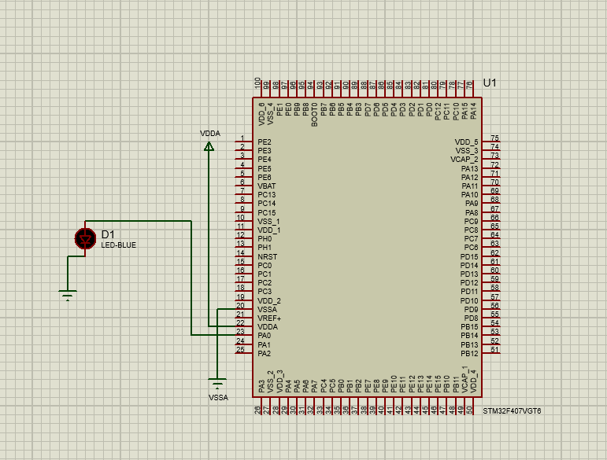
4. Right click>edit proterties on the controller and add the location of the hex file to run the code (option not coming up need to check ) 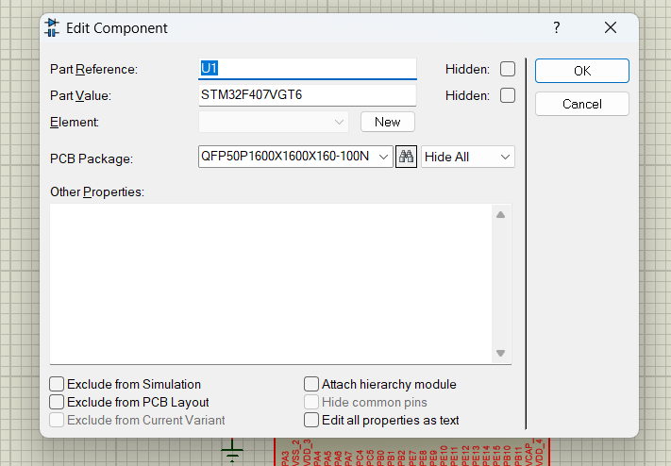

Resources:-

1. <https://www.youtube.com/watch?v=td6P7B0uce0>
2. <https://www.st.com/resource/en/product_training/STM32F7_System_RCC.pdf>
3. <https://engineeringxpert.com/how-to-simulate-stm32-project-in-proteus/>
4. <https://www.geeksforgeeks.org/how-to-download-and-install-proteus-software-on-windows/>
5. <https://www.youtube.com/watch?v=RVzkKagc6lI&t=95s>
6. <https://componentsearchengine.com>